Name: Jeanne Bufalino
Theme: Race and Ethnicity

School/Institution: TBD
Grade/Level: College/High Intermediate
Language: English
Course: ESL Academic Communications: Exploring topics on Art for Social Change
Topic: Addressing Art for Activism: Racism and Censorship of BLM Art

Rationale Statement:
Using content-based pedagogy, this ESL course will address topics related to Art and how it addresses and promotes social change, as well as societal reactions to the art. This particular lesson focuses on racism and how censorship of art alienates people, causes marginalized groups to be even less visible and contradicts the ideals of free speech in America. The course will focus on academic communications (reading, writing, listening and speaking skills) using research on topics, critical evaluation of art and perspectives related to social justice issues, and will provide students with skills to critique art and express opinions on topics through class discussions, reports, and student presentations.

Objectives:
Content Objectives | Language Objectives
- Students will demonstrate skills for engaging and addressing issues concerning the Black Lives Matter (BLM) movement and censorship of BLM art.  - Students will demonstrate different perspectives on how messages are conveyed in video and news articles. | - Students will orally demonstrate understanding of main idea and supporting details of different sources.  - Students will orally summarize similarities and differences of video and article sources.
Social Justice Objectives
- Students will understand power dynamics associated with censorship (of art) and how it influences the dominance and oppression of diverse social groups.
- Students will demonstrate awareness of structural inequities in society and how they are shaped by oppressive assumptions, biases, and prejudices that facilitate a stance of dominance, as well as identify where these biases, prejudices and assumptions rest in institutions.

Materials:
Appendix A:

Timeline: The Black Lives Matter movement. (2018, February 23). Retrieved from https://www.abc.net.au/news/2016-07-14/black-lives-matter-timeline/7585856.

Appendix B:
Agrawal, N. (2019, November 23). Students were illegally punished for Black Lives Matter posters, ACLU says. Retrieved from https://www.latimes.com/california/story/2019-11-23/sacramento-area-school-censored-students-artwork.

Appendix C:
Graphic organizer: Compare and Contrast Video and Article Sources

News Video:
Large, S. (2019, November 21). Elementary School Art Project Leads to Claims of Censorship. Retrieved from https://sacramento.cbslocal.com/2019/11/21/elementary-school-art-project-censorship/.

Homework/Research:
- Art and Culture Censorship Timeline. (2019, August 30). Retrieved from https://ncac.org/resource/art-and-culture-censorship-timeline.
- Selected artists from https://www.artsy.net/ & https://artandresponse.com/racism/

Procedures

Pre-Activities: Students preview the BLM topic | Time Frame | Objective(s) Targeted
Students investigate the BLM history: Sts Jigsaw (pairs) read the Timeline: The Black Lives Matter movement.  - Sts are randomly grouped into pairs, choose partners, or assigned partners/groups at the teacher’s discretion.  - Jigsaw: Each pair is assigned a section of the timeline. The timeline can be segmented into 14 or 15 sections (at the teacher’s discretion, the 15th section, “Where to from here?” can be included or omitted). For smaller classes, two sections could be assigned for each pair. For larger classes, three or four students can be assigned as a group.  - Sts read their portion of the timeline.  - Sts discuss the key information from their portion of the jigsaw with their partner/group.  - Sts prepare for the gallery walk: (1) Sts find pictures online (including pictures from their section of the time-lime, if applicable) and using laptops, create a digital collage (or identify a singular picture) that represents the events from their portion of the timeline, and (2) Sts determine with their partner/group what key points they will present for their portion of the timeline (3) Sts practice presenting their portion of the timeline with partners/group (all students must participate and present)  - In two groups, Sts complete Gallery Walk to share their portion of the timeline with the rest of the class  - As a whole class, Sts share their thoughts on the activity and any reflections they may have | 50 min | Content: A  Social Justice: F
Break | 10 min
During activities: Students compare and contrast sources (news video and news article) | Time Frame | Objective(s) Targeted
Discuss prior homework: Students pre-read the news article before class: Students were illegally punished for Black Lives Matter posters, ACLU says. (Appendix B)  - Discuss any questions students may have about the article  - Sts complete the “Article” section of the Compare and Contrast graphic organizer (Appendix B)  - Sts compare answers with a partner  - T calls on Sts to share-out their answers | 15 min | Language: C  Content: A
T plays the news video by Steve Large (November 21, 2019 at 11:52 pm): Elementary School Art Project Leads to Claims of Censorship  (Video can be played twice) | 5 min
Sts complete the “Video” section of the Compare and Contrast graphic organizer (Appendix C)  - Sts may independently re-watch the video (2-3 times) as they complete the video section of the chart  - Sts compare answers with a classmate  - T calls on Sts to share-out their answers with the class | 15 min | Language: C  Content: A
Sts complete the “Compare and Contrast” portion of the graphic organizer (Appendix C)  - Sts discuss with a partner the similarities and differences of the video and article  - Sts discuss as a group what the similarities and differences are between the article and the video  - Sts discuss with a partner which source they felt was more useful for researching and understanding the key information on the topic  - Sts complete the compare and contrast venn diagram section of the graphic organizer and answer the last question below the table independently about what they would like to learn more about.  - T calls on Sts to share-out their answers with the class | 20 min | Content: A  Content: B Language: D
Post Activities: Wrap-up | Time Frame | Objective(s) Targeted
Class discussion: Sts discuss the social justice issues and share their reactions to the article & video topic:  - Whose voices were highlighted in the news article and video?  - Why was the BLM art censored and not the other art?  - Who censored the art and whose voice(s) was/were censored?  - How do power dynamics play a role?  - How does art play a role in promoting social justice topics?  - Why are some people/art censored?  - What happens when art/people is/are censored?  - How would you react and what would you do if you were one of the students who was censored?  - Have you or someone you know ever been censored? What happened?  - What could you do to show support for the students that were censored? | 20 min | Content: B  Social Justice: E  Social Justice: F
Homework: Complete Step 1  Choose an artwork from one of the following sources (or find an example of your own) that focuses on issues related to race/ethnicity reflected through art. It can be any form of visual art (including film) from any era:  - National Coalition Against Censorship (NCAC) Art and Culture Censorship Timeline  - Michael D’Antuono: https://artandresponse.com/racism/  - David Hammons: https://www.artsy.net/artist/david-hammons  - Jimmie Durham: https://www.artsy.net/artist/jimmie-durham  - Shirin Neshat: https://www.artsy.net/artist/shirin-neshat  - Yinka Shonibare: https://www.artsy.net/artist/yinka-shonibare  - Faith Ringgold: https://www.artsy.net/artist/faith-ringgold  - Kerry James Marshall: https://www.artsy.net/artist/kerry-james-marshall  - Dox Thrash: https://www.artsy.net/artist/dox-thrash  - Gordon Parks: https://www.artsy.net/artist/gordon-parks  - Glenn Ligon: https://www.artsy.net/artist/glenn-ligon  - Dread Scott: https://www.artsy.net/artist/dread-scott  - Phoebe Boswell: https://www.huffpost.com/entry/this-woman-turned-racist-tinder-messages-into-thought-provoking-art_n_573a228be4b060aa781aefbd &  https://www.phoebeboswell.com/stranger-in-the-village/  - Shepard Fairey: http://www.artnet.com/artists/shepard-fairey/ & http://www.bmoreart.com/2017/02/banning-art-in-the-classroom-is-a-losing-battle.html  Step 1: Decide which work of art you want to research further. Answer the question: Why did you choose this example of art? Why are you drawn to it? (e.g. it’s visual aesthetic, its message, etc.) Be prepared to share your example and reason in the next class.  Step 2: Research the artwork: consider its history, influence, conflict, anything significant about the era that’s related to the art and/or artists message.  Step 3: Present:  - Describe the artwork (aesthetics, medium)  - Explain its cultural significance  - Discuss its historical relevance  - Identify any conflicts and/or racial issues associated with the artwork  - Discuss the artist’s message  - Share your reflection on the artwork | 5 min class time for explanation

Formative Assessment Strategy
The teacher will be facilitating the whole group discussions and monitoring students in pair work. They will be observing the students’ worksheets to confirm written work and observe students interacting to confirm participation in discussions. Students will also be observed for their presentation skills during the gallery walk.

Differentiation
Students have the opportunity to focus on an artwork and topic of their choice that they are interested in and relates to social justice issues they are concerned with in the homework assignment. Additionally, students will expand on the topic further during the research phase of the project.

Reflection
I have not taught this lesson yet. I think this would be a good lesson to introduce students to the BLM movement and to address structural inequalities in our society and how people of color are targeted based on their race and ethnicities. The lesson does not have a grammar focus, however, depending on the student’s needs I might modify the lesson to address concerns specific to my students’ needs. I think there are a variety of activities that will keep the students engaged. If there is not enough time for the lesson, I believe it can be easily split into two lessons, first introducing the BLM and then addressing the censorship of the BLM art on a second day.

Appendix A

Timeline: The Black Lives Matter movement
Updated 22 Feb 2018, 5:51pm
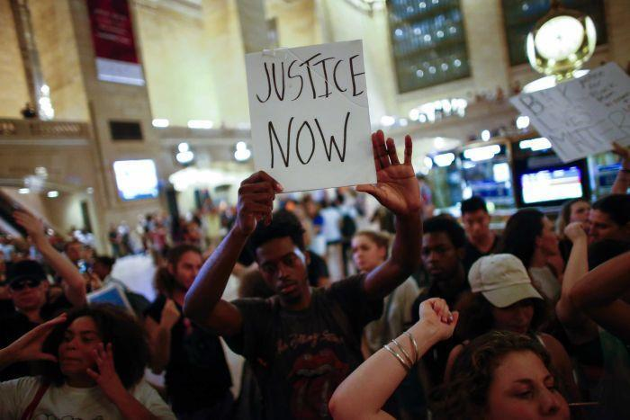Photo: A protest at Grand Central Station in New York on July 8, 2016. (AFP: Kena Betancur)
Related Story: Activists say 'clock is turning back on black people in America'
Related Story: Dallas mother thanks police officers for shielding sons from deadly attack
Related Story: Guns, racial tensions, mass death: A toxic mix America is unable to leave behind
As the United States continues to grapple with rising tensions over alleged police brutality against black Americans, we look at how a young man's walk to buy sweets in 2012 sparked a nationwide movement.
Here are the some of the key moments of the Black Lives Matter movement.

Trayvon Martin is shot by neighbourhood watch volunteer George Zimmerman

February 26, 2012
Trayvon Martin, 17, is fatally shot by neighbourhood watch volunteer George Zimmerman on a visit to the convenience store to buy a drink and sweets.
The teenager had been visiting his father's fiance in Sanford, Florida, when he had an altercation with Zimmerman.
Initially Zimmerman is not charged by Sanford Police. After a public outcry, Zimmerman is charged with second-degree murder and manslaughter.
The Black Lives Matter movement officially starts when Zimmerman is later acquitted of murdering Martin.
Zimmerman goes on to the sell the gun he used to shoot the teen for $US250,000.
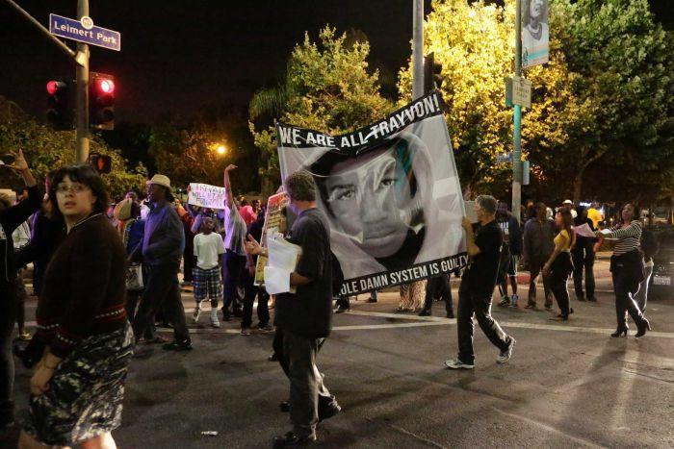Photo: Protesters march in the Leimert Park area of Los Angeles after the George Zimmerman verdict on July 13, 2013. (Reuters: Jason Redmond)

Jordan Davis is shot at a gas station in Jacksonville, Florida

November 23, 2012
African-American teenager Jordan Davis, 17, and his three friends are stopped in a gas station parking lot to buy gum and cigarettes.
They are approached by white man Michael Dunn and after an verbal argument about the volume of the teenagers' music, Dunn shoots 10 rounds into their car, killing Davis.
Dunn is sentenced to life in prison without parole. Davis' death is the focus of documentary film 3½ Minutes and becomes part of the national conversation about the dangers facing young black men in America.

Renisha McBride is shot dead in Detroit after a car accident

November 2, 2013
Renisha McBride, 19, knocks on the door of Theodore Wafer's home in the early hours of the morning after she is involved in a car crash in Detroit, Michigan.
Wafer fatally shoots her through his door.
The case initially stirs racial tensions because Wafer is white and McBride was black. Her supporters rally in Detroit after her death and online activists launch a campaign for justice.
Wafer receives a 17-year sentence for a raft of charges which includes second-degree murder and manslaughter.

'I can't breathe' - Eric Garner is choked to death on Staten Island, New York

July 17, 2014
Eric Garner, 43, is killed by NYPD officer Daniel Pantaleo after being put in a chokehold on the side of the road.
A bystander films the footage of the 43-year-old father gasping for air and saying "I can't breathe" before turning limp.
The phrase becomes a key part of the Black Lives Matter movement.
Protests erupt in New York after a grand jury fails to indict the officer.
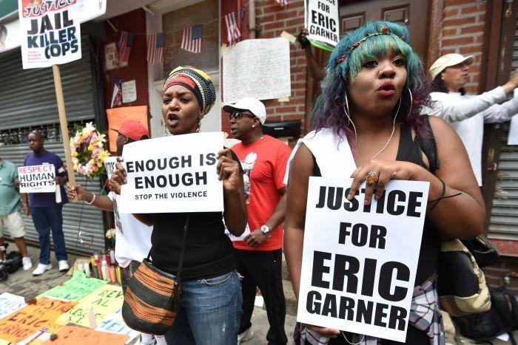Photo: Protesters gather at the spot where Eric Garner died. (AFP/Stan Honda (file))

John Crawford is killed by police at a Walmart in Ohio

August 5, 2014
John Crawford, 22, is shot dead by police after being seen with a toy gun, which he picked up in the store.
He and his girlfriend were at the Walmart store in Beavercreek, Ohio, to pick up crackers, marshmallows and chocolate bars for a family gathering.

Unarmed teenager Michael Brown is killed in Ferguson, Missouri

August 9, 2014
Unarmed teenager Michael Brown is killed by officer Darren Wilson outside of an apartment complex in Ferguson, Missouri.
Just two days later on August 11, Ezell Ford, who according to his family has a mental disability, is killed by Los Angeles police officers while walking in the street.
An autopsy shows Ford had been shot in the back at close range.
A state of emergency is declared in Missouri after protests turn violent.

Laquan McDonald is killed by officer Jason Van Dyke in Chicago

October 20, 2014
Laquan McDonald, 17, is shot 16 times in 13 seconds by police officer Jason Van Dyke after he refuses to drop a three-inch knife in Chicago, Illinois.
Dash-cam footage of the incident is released by officials on November 24, 2015, prompting hundreds to protest.
Chicago Mayor Rahm Emanuel fires the city's police superintendent Garry McCarthy over his handling of the shooting.
Van Dyke is charged with murder.

Tamir Rice is shot by a police officer after carrying a toy gun in Ohio

November 23, 2014
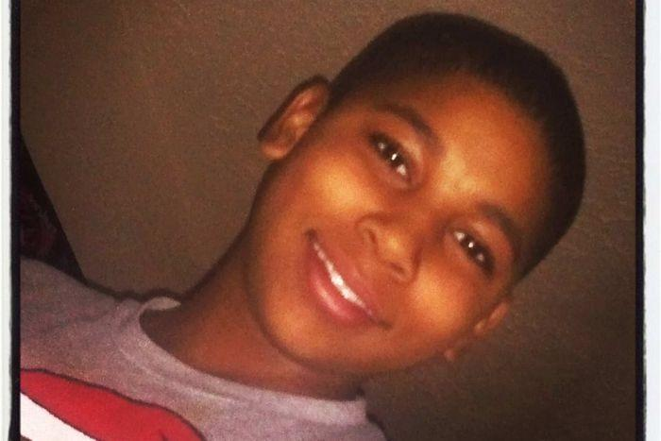Photo: 12 year old Tamir Rice was shot and killed by police in the US city of Cleveland. (AFP: Family Photo via Richardson & Kucharski co.)
Tamir Rice, 12, is seen pointing a gun at random people Cleveland, Ohio. A call is made to police. The caller says the gun is "probably fake", but the information is not relayed to the attending officers.
Within seconds of arriving on the scene, police officer Timothy Loehmann fires two shots, hitting Rice in the torso. Rice dies the next day.
A Cleveland grand jury declines to bring charges against Loehmann and his partner Frank Garmback.
A month later, two New York Police officers are shot dead in an ambush on December 20 in Brooklyn following protests.

Freddie Gray is arrested in Baltimore, dies after sustaining injuries in police custody

April 12, 2015
Freddie Gray runs after seeing police in Baltimore, Maryland. The 25-year-old is arrested for possessing what they describe as an illegal switchblade.
Requests for his inhaler are ignored. He is put into the police vehicle without a restraint, against police policy.
While being transported in a police van, he falls into a coma. He dies on April 19 from injuries to his spinal cord.
Demonstrators take to the streets and the National Guard is dispatched in an attempt to restore order.
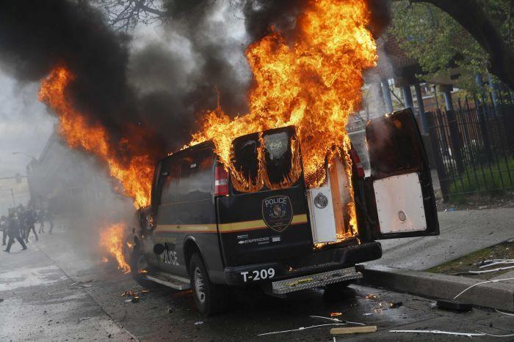Photo: A Baltimore Metropolitan Police transport vehicle burns during clashes in Baltimore, Maryland April 27, 2015. (Reuters: Shannon Stapleton)
Just months later, Sandra Bland, 28, is found hanged while in police custody in Texas, on July 13.
She had been pulled over for a minor traffic violation on July 10.

Jamar Clark is shot by police in Minneapolis

November 16, 2015
Jamar Clark, 24, is shot in the head by police, with some witnesses claiming he was handcuffed at the time
The Black Lives Matter movement protests outside the Fourth Precinct police station for 18 days.
No charges are filed against police officers Mark Ringgenberg and Dustin Schwarze.
Days later Akai Gurley is in the stairwell of a Brooklyn apartment building on November 20 when he is shot dead.
New York police officer Peter Liang is subsequently charged with murder.

Anton Sterling is shot five times in the chest at close range by police

July 5, 2016
Two videos capture the moment Alton Sterling, 37, is pinned down to the ground and shot five times in the chest at close range by police outside a convenience store at Baton Rouge, Louisiana.
Police call for calm after major protests kick off in Baton Rouge after the video is released.
Federal authorities say they will handle the investigation, led by the Department of Justice's civil rights division.
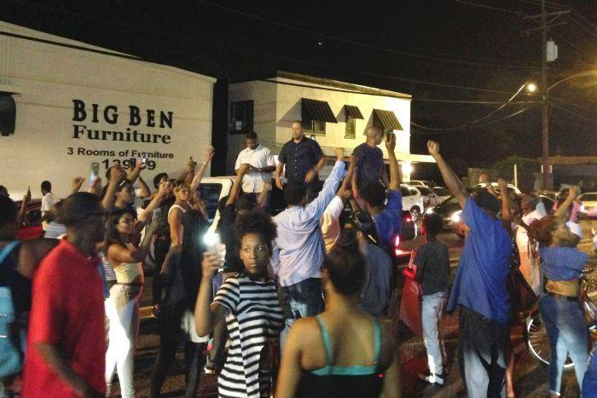Photo: People protest after Alton Sterling, 37, was shot and killed during an altercation with two police officers. (Reuters: Jim Tanner)

Diamond Reynolds live streams aftermath of boyfriend's shooting

July 6, 2016
Diamond Reynolds uses Facebook Live to stream the fallout of her boyfriend Philando Castile being shot by police in Minnesota.
He is allegedly shot by a police officer while reaching for his wallet after being pulled over.
Castile later dies in hospital.
The video has been viewed more than 5.6 million times.

Five police officers are killed by a sniper at a Black Lives Matter protest in Dallas

July 7, 2016
A peaceful Black Lives Matter turns to mayhem as a gunman shoots and kills five police officers.
US President Barack Obama describes the attack at "vicious, calculated and despicable".
Here's ABC Washington DC bureau chief Zoe Daniel:
The deliberate attack on police in Dallas has shocked a nation used to shootings and connected race relations and gun violence, arguably America's two most intractable problems.
Before he was killed, the Dallas shooter told police that he was killing white officers as payback for the deaths of Alton Sterling who was shot point blank by police in Louisiana last week and Philando Castile who bled out live on Facebook after being shot by police in Minnesota.
It has once again opened a divide, and a heated conversation, about racial profiling.
Consider this from the Washington Post: "...black Americans are 2.5 times as likely as white Americans to be shot and killed by police officers".
Statistics show that plenty of white people get shot by police too, but as a percentage of the population African Americans are dramatically over represented.

Charles Kinsey is shot while trying to help patient with autism

July 22, 2016
Unarmed black man Charles Kinsey is shot and injured in Miami while lying on the ground with his arms raised in the air and pleading with officers to hold their fire.
Mr Kinsey's leg was injured in the incident, which came as he tried to help a disoriented autistic man who had wandered away from a group home where Mr Kinsey works as a behavioural therapist.
Mobile phone footage showed Mr Kinsey on the ground with his arms in the air, with the young autistic man sitting on the ground nearby playing with a small white toy.

Where to from here?
Zoe Daniel writes:
Mr Obama has said "America is not as divided as some have suggested", trying to calm a population fearing race riots will break out.
Yet others have dubbed the nation a 'powder keg' as nervous police and Black Lives Matter activists face off at protests around the country.
Again, the nation's first black President has called for calm.
"You're not seeing riots and you're not seeing police going after people who are protesting peacefully," he says.
"You've seen almost uniformly peaceful protests and you've seen, uniformly, police handling those protests with professionalism."
But tension is high. Another incident may well light the fuse.

Appendix B

Students were illegally punished for Black Lives Matter posters, ACLU says

[LA Times online headline]

Students’ art was censored, ACLU alleges: Group says pupils were punished for making posters in support of Black Lives Matter movement.
[LA Times printed headline]
By: Nina Agrawal (Staff Writer)
Nov. 23, 2019
12 PM
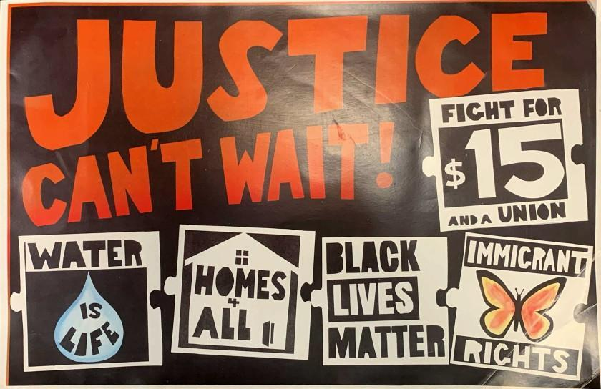
Isela Bravo ACLUA POSTER referencing Black Lives Matter was part of a lesson on art and activism led by a volunteer. Four elementary school students who created Black Lives Matter posters were improperly forced to redo their art assignment, the American Civil Liberties Union says. (Isela Bravo / American Civil Liberties Union)

A group of young Sacramento students was unlawfully singled out and punished for creating posters that supported the Black Lives Matter movement as part of an art class led by a parent volunteer, the American Civil Liberties Union said.

Four students at Del Paso Manor Elementary School created the works after a lesson on how art is used in activist movements. They were improperly forced to redo their posters during class time, the civil liberties group said in a letter to the San Juan Unified School District this week. One student’s art was thrown away.

“By censoring and punishing the students, the school violated their constitutional free speech rights and sent the damaging message that supporting black lives is not welcome in their classrooms,” Abre’ Conner, staff attorney at the ACLU Foundation of Northern California, said in a news release.

The school also violated the 1st Amendment rights of the parent who led the students’ art lesson in September by banning her from returning to the classroom in retaliation for speaking to the principal about the incident, the ACLU said.

A district official said in an emailed statement Friday that the allegations are serious and that the district is investigating. However, there are inconsistencies between the ACLU’s account, the district’s prior knowledge of the incident and what it has learned since receiving the ACLU’s letter on Thursday, said Raj Rai, the district communication coordinator.

“It is inconsistent with our values and never our intent or desire for any student to feel uncomfortable or unwelcome to discuss issues that are important to them. We sincerely apologize if this experience made any student feel such discomfort,” Rai said.
“Censoring a student’s assigned work because of its content would not be acceptable.”
According to the ACLU letter, a Del Paso Manor parent and frequent volunteer identified only as Ms. Kincaid taught a lesson on art and activism as part of the school’s “art docent” program on Sept. 16. She showed posters that referenced immigration, housing rights and Black Lives Matter, among other topics.

After the lesson, the students were assigned to focus on a change they wanted to see at their school. Four students created Black Lives Matters posters, including one who used paper and markers to depict people holding hands and a sign that said “Black Lives Matter.”

The students’ teacher, David Madden, made those students redo their posters because they were “inappropriate and political” and threw one student’s art in the trash, the ACLU said.

Kincaid sought out the school’s principal, who told her that Black Lives Matter lessons are political statements and could not be displayed publicly, the ACLU said.
Publicly available documents for Del Paso Manor’s school site council reference a parent community member named Magali Kincaid. Reached by phone, Kincaid declined to talk, referring a reporter to the ACLU.

Del Paso Manor Elementary referred inquiries to the district’s communications office.
Rai’s statement said art docent volunteers are supposed to be trained and deliver district-developed lessons, which Kincaid did not do.

The statement also said that the students had been assigned to produce artwork specifically related to a change they wanted at the school, and those whose artwork focused on larger social issues were asked by the teacher to complete another poster the next day.

Only the art that “met the assignment’s purpose,” not the Black Lives Matter posters, was ultimately displayed in Madden’s classroom.
The ACLU has asked the district to issue a public apology, allow Kincaid to continue volunteering in the classroom, display the Black Lives Matter posters during its spring “art night,” and undertake cultural and sensitivity training for staff.

Appendix C Compare and Contrast Video and Article Sources

 | Video | Article
Title:
Main Idea:
Key Details:

Compare and Contrast: How is the news in the media presented differently in the video versus the news article? How are they similar and different? (For example: Whose voices are represented in each medium? What perspectives are presented? How is the information presented? Are the facts supported? If yes, how? Are the facts the same?)

News Article: News Video:
________________________________________________________________________________________________________________________________________________________________________________________________________________________________________________________________________________________________________________________________________________________________________________________________________________________________________________________________________________________________________________________________________________________________________________________________________________________________________________________________________________________________________________________________________________________________________________________________________________________________________________________________________
_________________________________________________________________________________________________________
________________________________________________________________________________________________________________________________________________________________________________________________________________________________________________________________________________________________________________________________________________________________________________________________________________________________________________________________________________________________________________________________________________________________________________________________________________________________________________________________________________________________________________________________________________________________________________________________________________________________________________________________________

Do you feel one source is more useful for researching and understanding the key information on the topic? Which one? How?
___________________________________________________________________________________________________________________________________________________________________________________________________________________________________________________________________________________________________________________________

